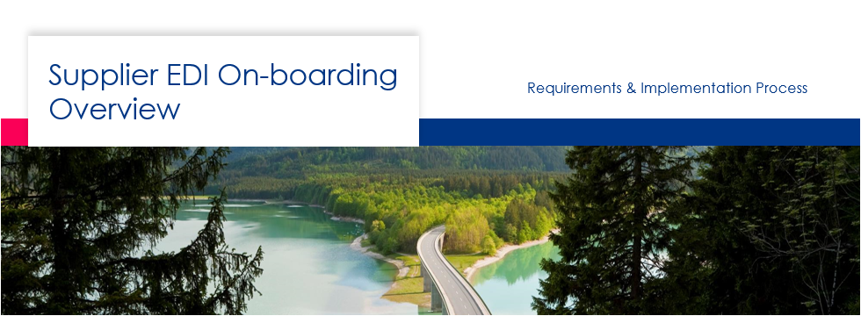

Contents
1 Introduction 3
2 EDI and our Standards 4
2.1 Why do EDI? 4
2.2 EDI message types and standards 4
2.3 Faurecia release (forecast) options 6
3 Supplier On-boarding overview 7
4 On-boarding Steps Details 8
4.1 Faurecia initiates internal request 8
4.2 EDI Clearing Center sends parameter sheet to vendor 9
4.3 Supplier sends EDI Parameter Sheet 9
4.4 EDI Clearing Center validates EDI Parameter Sheet 9
4.5 Supplier Technical EDI setups with Supplier 9
4.6 EDI Clearing Center sends a test DELFOR (DELJIT if applicable) 10
4.7 Supplier acknowledges test message 11
4.8 Supplier sends a test ASN via Self-Test process 11
4.8.1 How to Submit a TEST ASN (DESADV or INVOIC) 12
4.9 Supplier sends same test ASN to Production 14
4.10 EDI Clearing Center validates and certifies ASN 15

Introduction
This document is an overview of how Faurecia will be doing the Supplier EDI on-boarding with its external supply base.
- Faurecia requires all Suppliers to be EDI capable
- Suppliers should have a DUNS number for North America plants they will be shipping to; if you don’t have one, please register at dnb.com
- EU Suppliers are not mandated to use a DUNS# per EDI regulations in EU
- Suppliers must have the ability to receive both long term and short term delivery schedules
- Advance Ship Notices (ASN) are mandatory when shipping
- EDI implementation guidelines can be found at https://www.faurecia.com/en/edi-portal
- Faurecia EDI Clearing Centre is key contact for Supplier On-boarding or questions about testing and connectivity issues (edi@faurecia.com)
- Always reference the Requestor’s ticket number when applicable for support
- Faurecia has two release processes. Each process has different requirements and Supplier must know what process they are on (levelled=“LISA” or not levelled=“NO LISA”) Your planner can give you details of your requirements

EDI and our Standards

Why do EDI?
“Electronic Data Interchange (EDI) is the computer-to-computer exchange of business documents in a standard electronic format between business partners”
BENEFITS
- Cost Savings
- Speed
- Accuracy
- Efficiency
FINANCE & MANUFACTURING GAINS
- Plant processes will improve, and reception is automated
- 3-way match process as EDI logistics improves NRFT
- Accounts payables processes will be more efficient
- Supplier invoices are matched earlier

EDI message types and standards

EDIFACT  Message | Direction  (From Faurecia) | Logistic Flow | Comment
DELFOR D96A, D97A | Outbound | Long term forecast Mixed  (long+firm) | Levelled (LISA)  Non-levelled (NO LISA)
DELJIT D96A, D97A | Outbound | Short term forecast  (manifest) | Levelled (LISA)
INVOIC D96A | Outbound (Self-Bill)/  Inbound | Invoice to Supplier /  Invoice from Supplier | Can be requested separately
INVOIC D07A | Outbound | Self-bill to Supplier | Can be requested separately
DESADV D96A, D97A | Inbound | ASN to Faurecia | Levelled or Non-Levelled

Faurecia release (forecast) options
LEVELLED RELEASES (the normal standard)
- LISA releases both a DELFOR and DELJIT message (2 separate EDI messages)
- Supplier must ship according to DELJIT (manifest) in LISA
- DELFOR contains only long-term forecast
- Does not provide cumulative figures, or last receipts
- ASN must be sent according to Manifest (DELJIT)
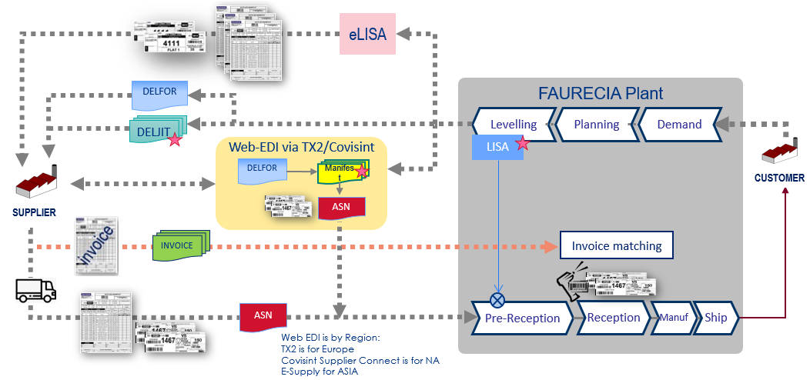

NON-LEVELLED RELEASES (NO-LISA)
- Only a DELFOR is sent to the supplier which can have both long and short-term planning
- ASN is still required for NO LISA flows
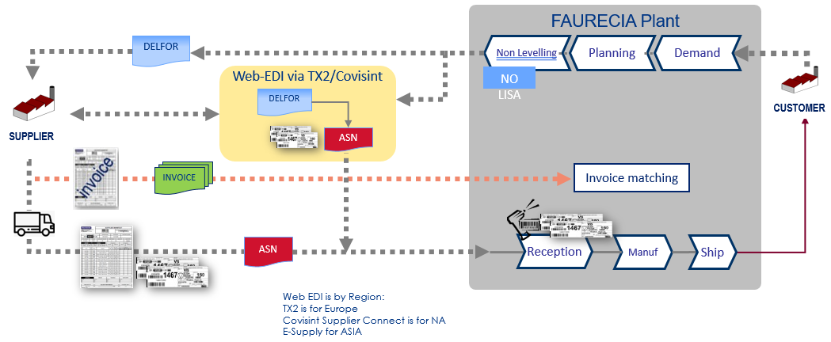

Supplier On-boarding overview
Suppliers should follow the Onboarding process flow below.

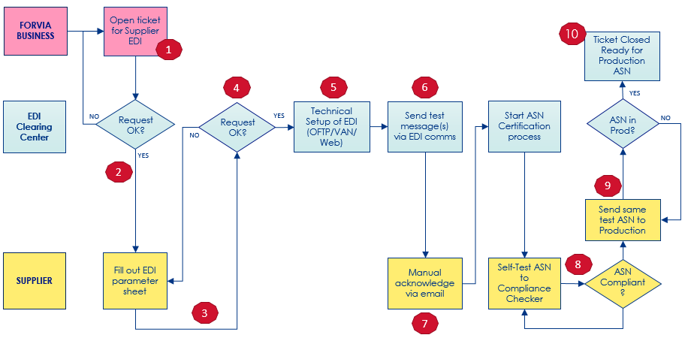

- Faurecia Buyer/PC&L (“Requestor”), internally creates a ticket in Faurecia system to initiate a new Supplier On-boarding request
- Faurecia EDI Clearing Center will send EDI parameter sheet to vendor contact
- Supplier fills out EDI parameter sheet and sends it back to EDI Clearing Center
- Faurecia validates EDI parameter sheet & initiates communication procedures
- Supplier setups up communications with Faurecia (VAN/P2P,Web)
- EDI Clearing Center sends a test DELFOR (DELJIT if applicable)
- Supplier acknowledges the reception of messages via email
- Supplier sends a test ASN via Self-Test process
- Supplier sends same test ASN to production
- EDI Clearing Center validates and certifies Supplier ASN

On-boarding Steps Details

Faurecia initiates internal request
- Faurecia Buyer/PC&L “Requestor” will initiate a new supplier EDI request via Faurecia internal ticketing system
- step is mandatory and no request will be processed without an internal ticket or project number
- Supplier should provide the EDI contact for this setup process as it will be needed by the Requestor to open a ticket
- Supplier is to reference the Ticket#/Project# for any setup/support issues during the process
Optional (Vendor initiates request)
- The supplier can be pro-active as well by navigating to Faurecia EDI portal https///www.faurecia.com/en/edi-portal and download the EDI parameter sheet
- Form should be filled out 100% (forms not filled out correctly are not processed)
- Supplier then sends the form back to the “Requestor” to enter in Faurecia Ticketing system
- Forms submitted directly to EDI Clear Center without a Faurecia ticket reference number will not be processed

EDI Clearing Center sends parameter sheet to vendor
- Supplier will receive EDI parameter sheet from EDI Clearing Center via email
- Supplier fills out all fields required
- Click the “Validate Form & Email to Faurecia EDI Team” button to check that all parameter areas are filled out
- If all sections are “Passed” then you can send the parameter form back to Faurecia

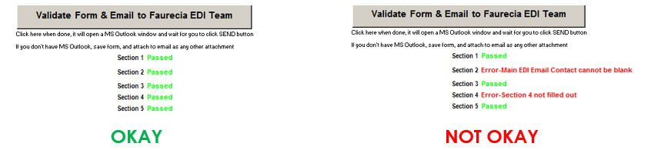

Supplier sends EDI Parameter Sheet
- Upon receipt of parameter sheet, it will be validated against the Ticket/Project number
- If form has missing information, it will be rejected and sent back to the sender’s email

EDI Clearing Center validates EDI Parameter Sheet
- If parameter sheet is okay, Faurecia will initiate the next task and being
to setup the internal EDI parameters for the request

Supplier Technical EDI setups with Supplier
Standard EDI Communications (VAN setups OpenText/GXS/Covisint)
- Faurecia will request a trading partner provided with our VAN
- Supplier should approve the request if needed on their end
- Inter-connect setups: Supplier to ensure the inter-connect is established between sender/receiver IDs with Faurecia’s VAN
P2P Connections (OFTP2)
- OFTP2 selection is supported in the parameter sheet in sections 3 & 4
Web EDI Option (Covisint/TX2/E-SupplyWeb-ASIA only)
- Faurecia Plants in North America are supported by Covisint only
- Faurecia Plants in Europe are supported with TX2 only
- Faurecia Plants in ASIA are supported with E-Supply only

EDI Clearing Center sends a test DELFOR (DELJIT if applicable)
- EDI Clearing center will send a “test” message against the logistics flows that was authorized (DELFOR (LISA/NO LISA) and/or DELJIT (LISA)
- The EDI message will have your supplier code (if available) and 2 materials with test data in the message (i.e.: material and PO# will by dummy data based on our standards)
- EDI Clearing center will email the Supplier to advise a first test message was sent via EDI communications (no test messages are sent via email)

Supplier acknowledges test message
- Supplier needs to send an email back to EDI Clearing Center advising they have received the test message(s)
- Supplier’s email subject should reference the Ticket/Project reference number and their supplier code
- Failure to send a manual acknowledgment via email within 2-3 days will stop the on boarding process and will be escalated to the Requestor where your request will be marked as incomplete, and you will need to re-start the entire process again

Supplier sends a test ASN via Self-Test process
- Supplier should create a test ASN based on the test DELFOR (DELJIT if applicable) and send it to the Faurecia’s ASN Compliance Self-Assessment tool
- ASN check tool will validate the structure, segments and elements are within Faurecia EDI specifications (data quality validation is done once ASN is Compliant, and in Production, post Supplier ASN Certification)
- Supplier submits a test ASN via email attachment, and an automatic email will be generated back to the Supplier with the results
- ASN testing must be done until Supplier see’s a result of “COMPLIANT”
- Supplier is highly recommended to test all business cases for ASN types so that future
re-certification can be skipped, should the supplier be requested to be on LISA
- LISA –this requires the manifest number to be in the ASN + Packaging
- NO LISA –this requires normal ASN + Packaging
- Please review the EDI specifications on DESADV for samples

4.8.1 How to Submit a TEST ASN (DESADV or INVOIC)
- Send your test ASN to: asnchecker@faurecia.com
- Send your test INVOICE to: invoicechecker@faurecia.com
- The attachment must NOT be compressed/zipped and must have the extension “.txt” which is case sensitive
- Message should be a wrapped EDI file (ie: NO CR/LF on each line segment) example:
UNB+UNOC:2+SENDERID:01....'UNH+000001100+...'BGM+351+123456...'DTM+11:2019...'DTM+132:..etc...everything should be on 1 line
- Subject should only have your Ticket Reference number or Supplier Code used throughout this process
- Do not send emails for support to this email address, it is only used for the ASN testing automation process. Should you need additional support send an email to edi@faurecia.com and include your Ticket #
Example of ASN checker email:
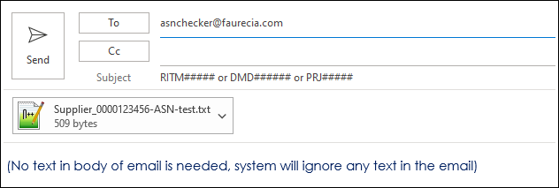
- You should receive a response within 5-10 minutes provided that:
- the EDI parameter sheet in Section 2 (EDI email contact) was filled out
- the message was sent according to requirements and format of the email
There are 3 Results:
- COMPLIANT – ASN is good
- COMPLIANT WITH WARNINGS –ASN is valid but breaking Faurecia business rules and should be corrected
- NOT COMPLIANT –ASN must be re-tested, and is not valid for production, you must re-test until you get a “COMPLIANT” response report

Sample response:
COMPLIANT RESPONSE:
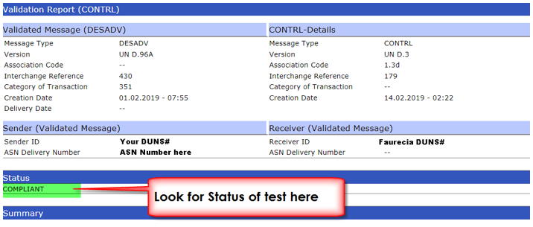

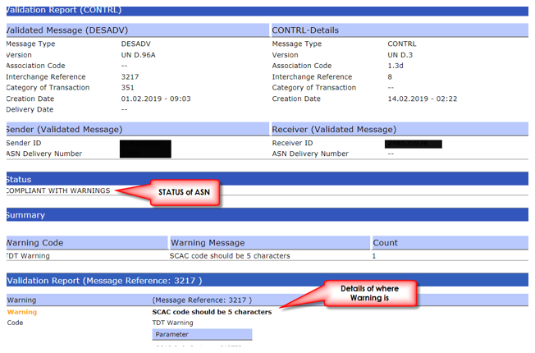
COMPLIANT WITH WARNINGS:

NOT COMPLIANT:
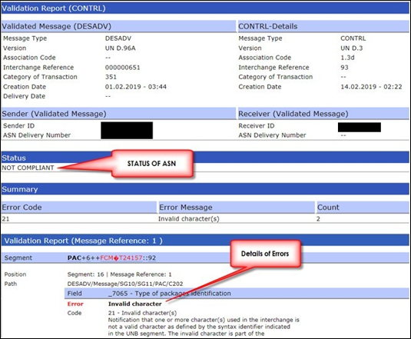

Supplier sends same test ASN to Production
- Once the Supplier receives a “COMPLIANT” response from Step 8, Supplier needs to email EDI Clearing Center (reference the Ticket # in subject) and advise when then can send the same “test” ASN to our production system so it can be validated
- There is no impact to our Production system provided the ASN being sent is using the “dummy” data from the test DELFOR/DELJIT message in prior steps (A Valid Supplier Code must be used in RFF+ADE (D96A) or NAD+SU (D97A), and invalid material number and purchase order number must be used)

EDI Clearing Center validates and certifies ASN
- EDI Clearing Center will review if ASN was loaded into production and
will advise the Supplier if Certification is completed or if further testing is needed
- Once “Certified” the Supplier can start sending ASN’s to production

